**PART 1: Run a docker tutorial**

1. Running the container

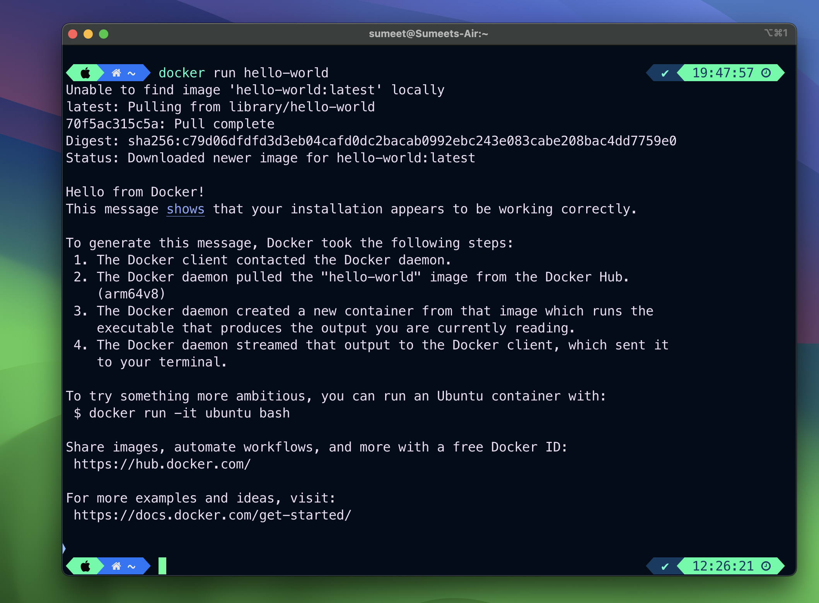

1. Under the covers

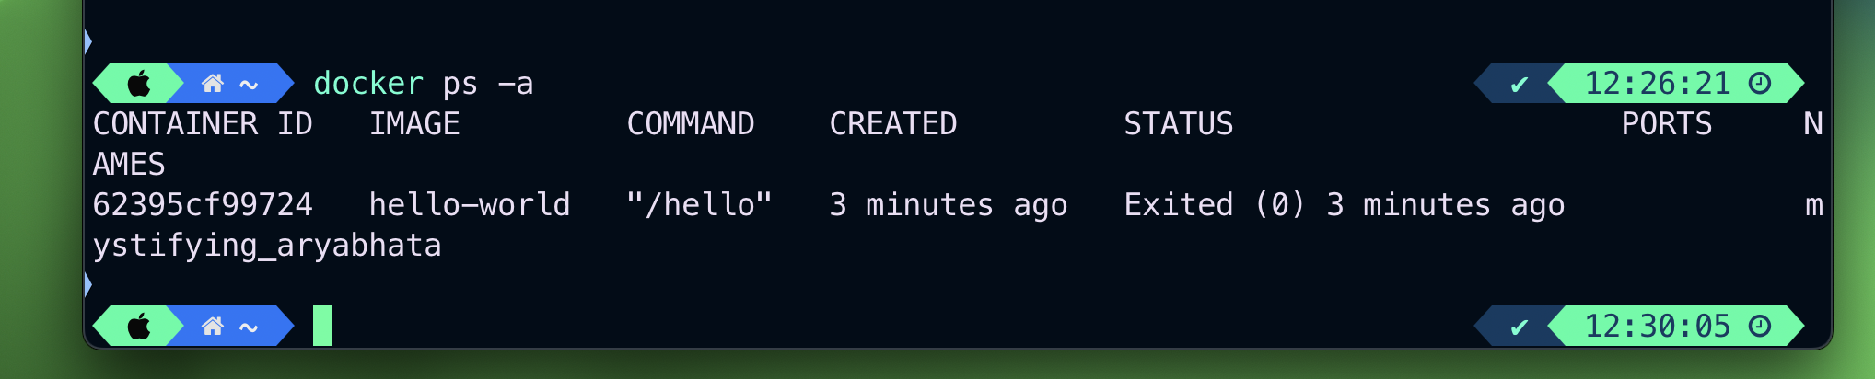

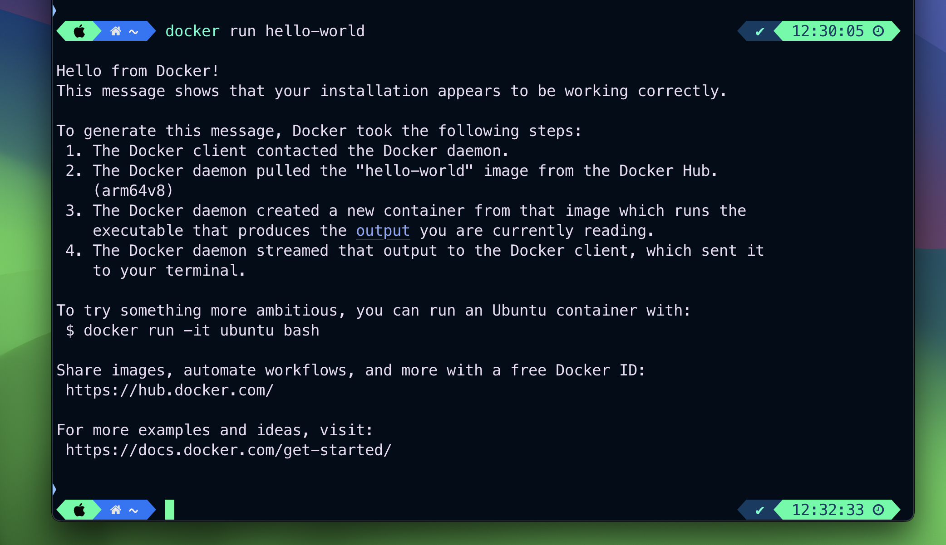

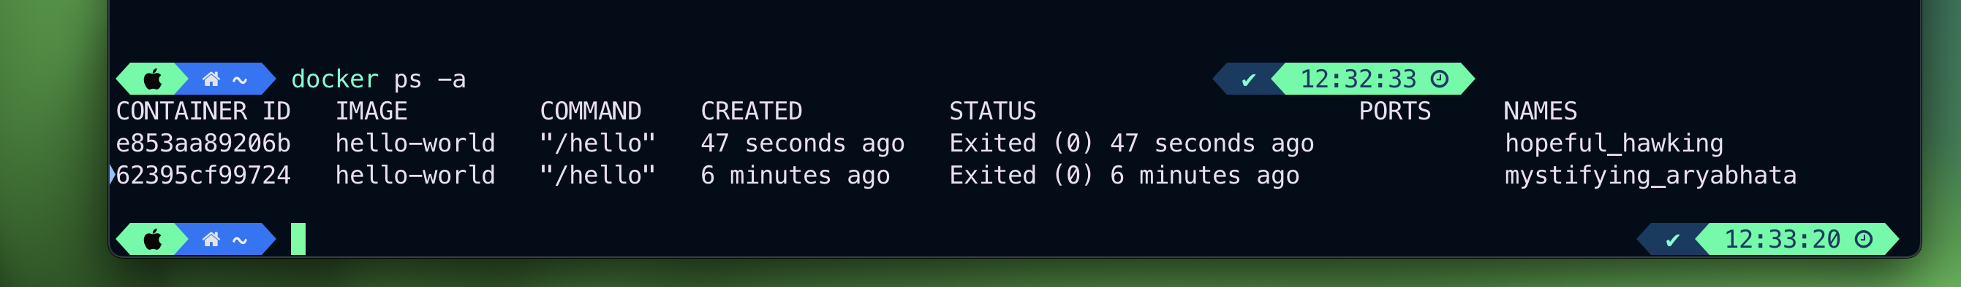

1. Reuse a container

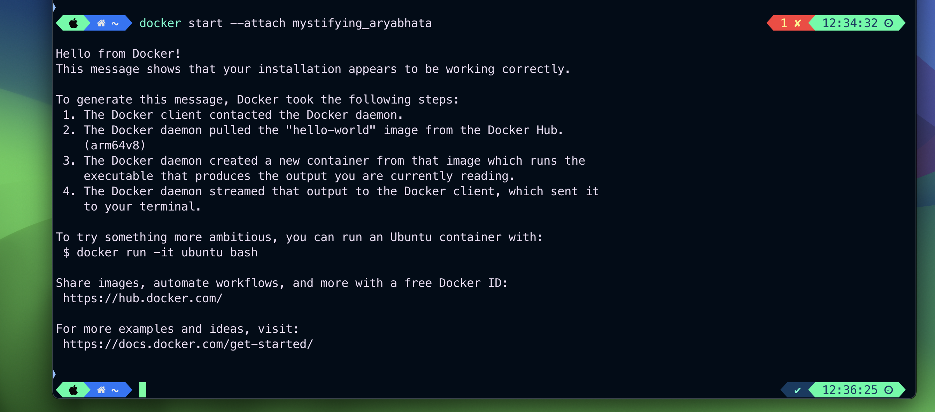

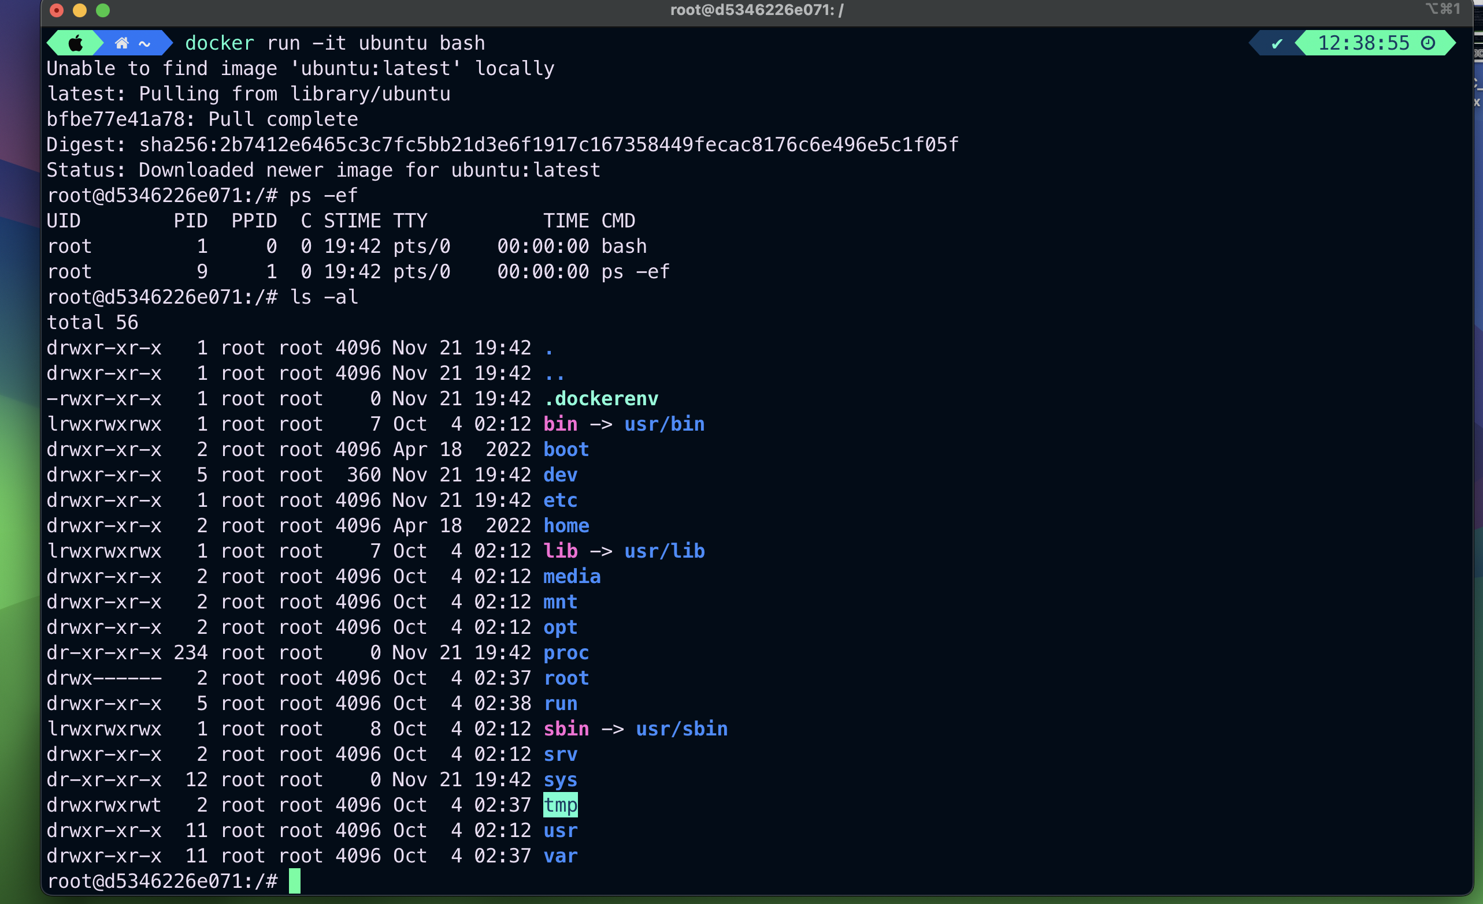

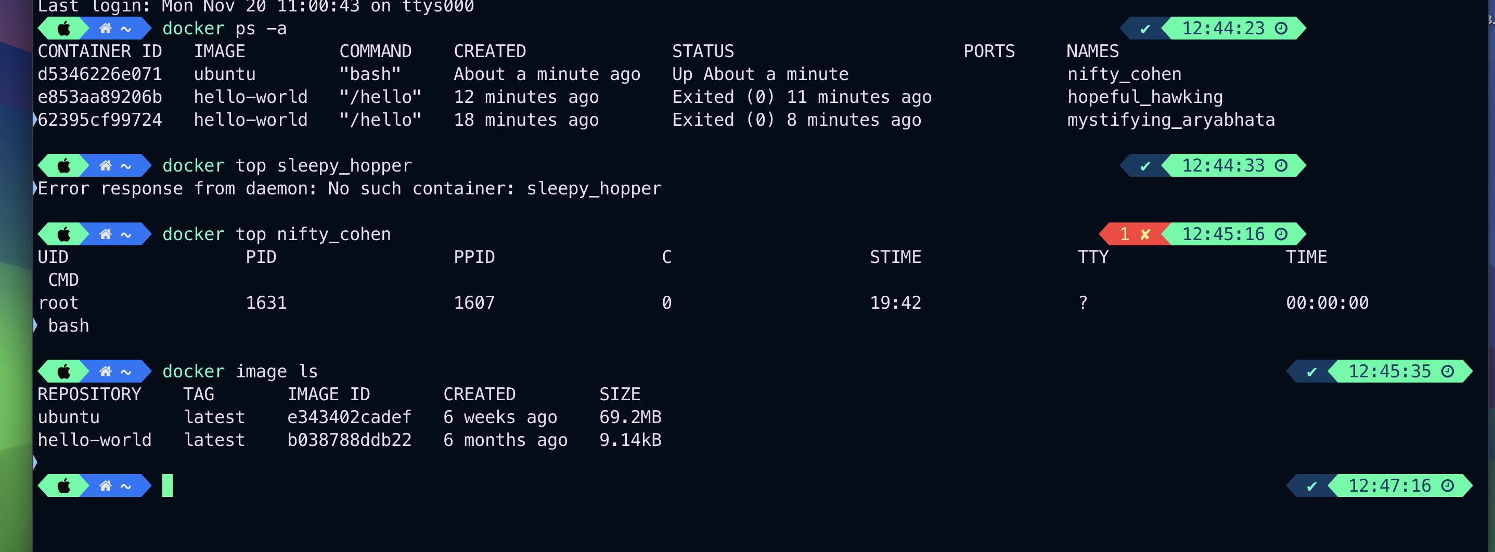

1. Share system resources with a container



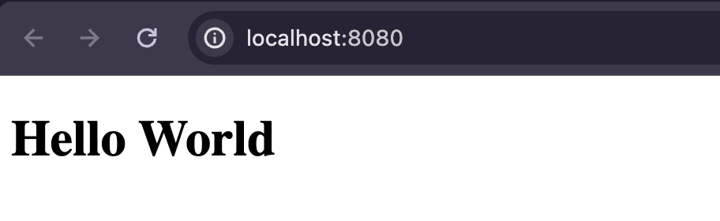

1. Stop and Remove a container





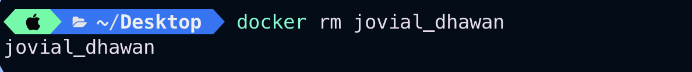



1. Create a docker image, run a custom image

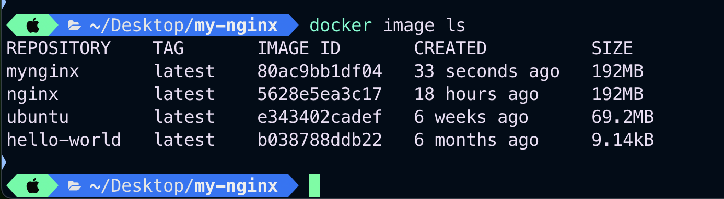

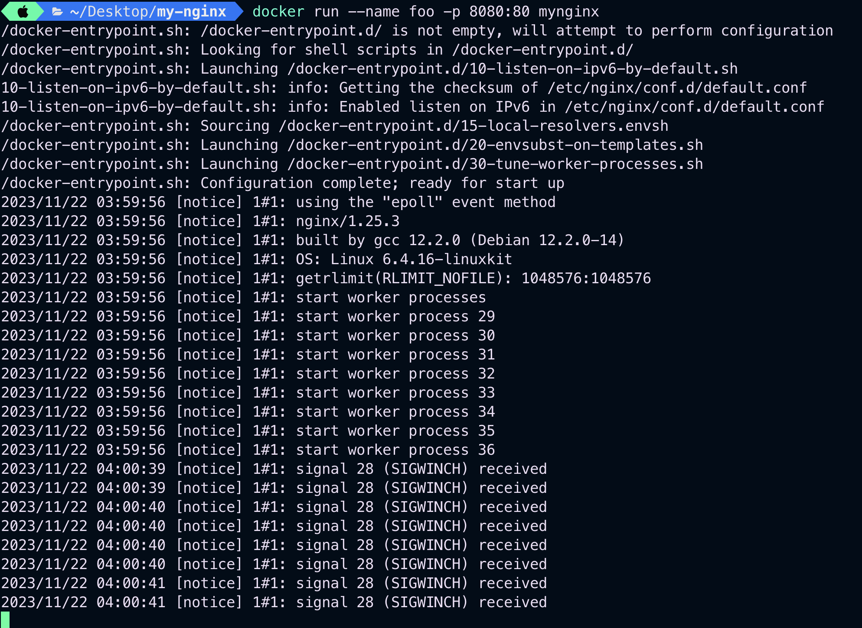



1. Create a more customized image

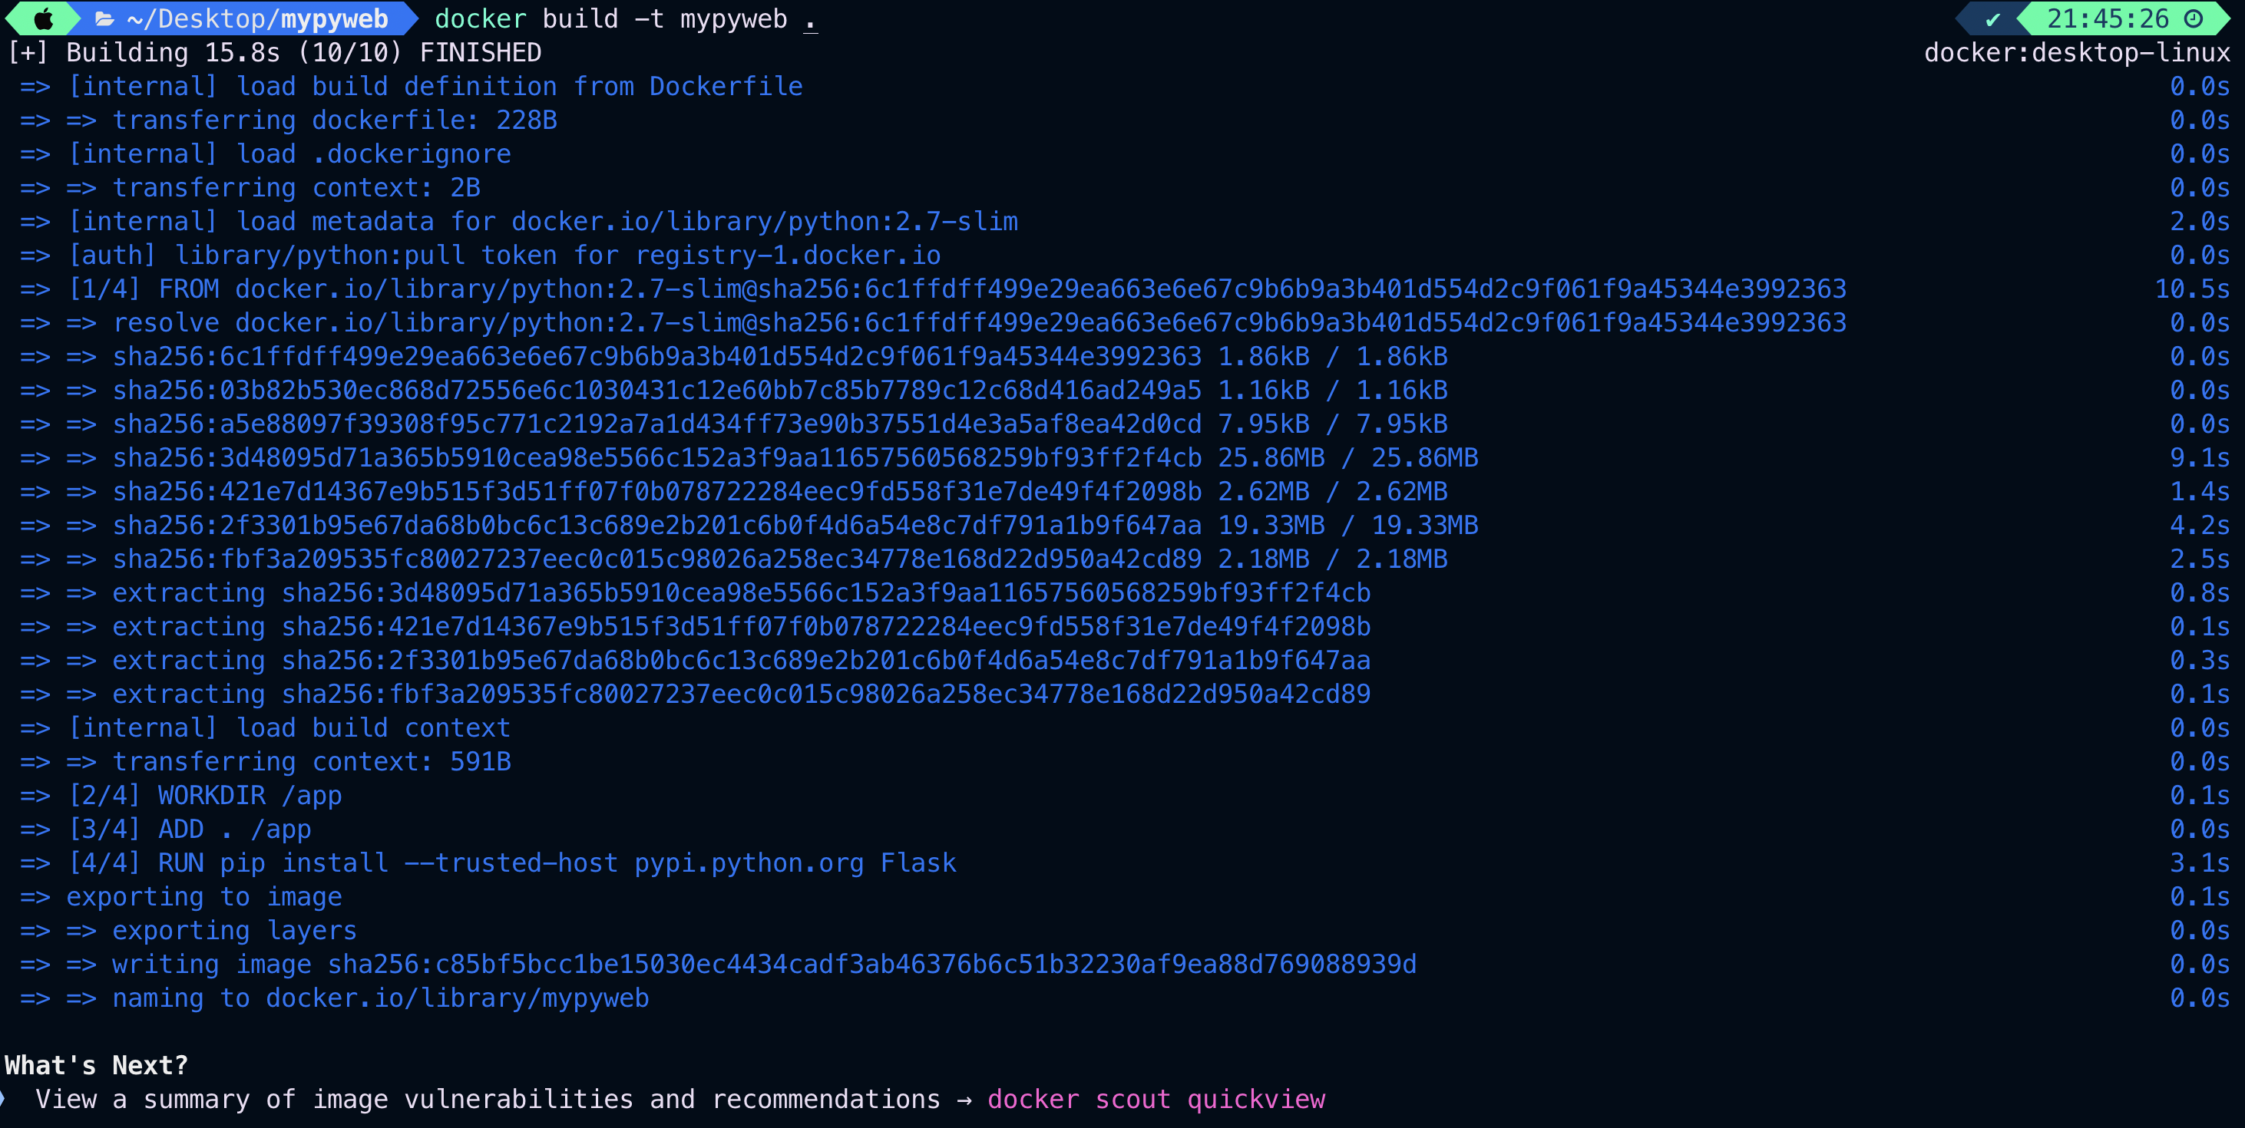

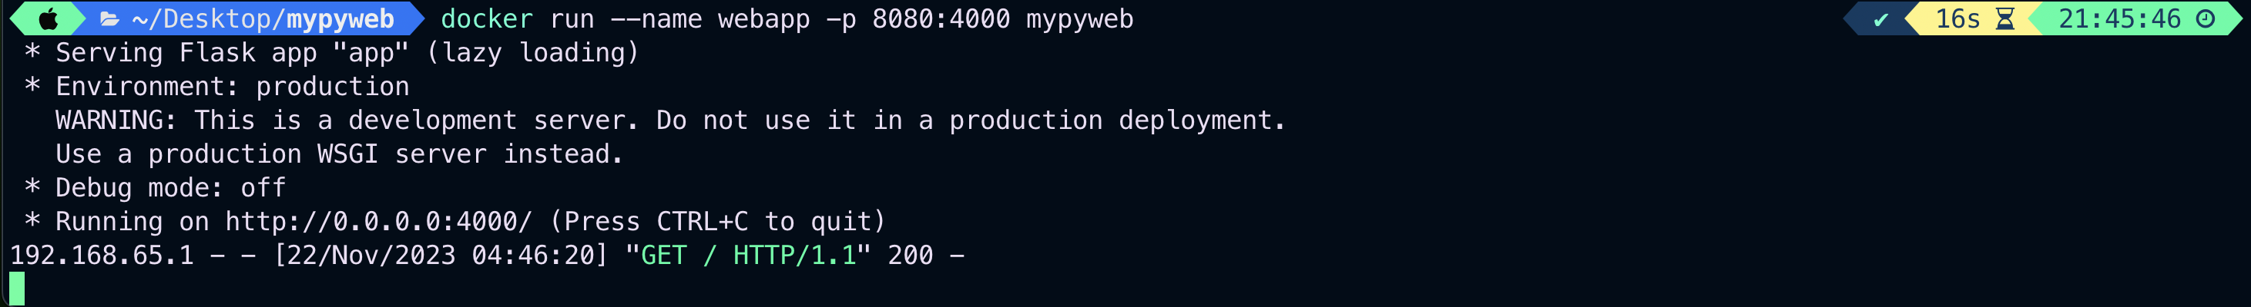



1. Run our Python image with Pass environment variables and Hello

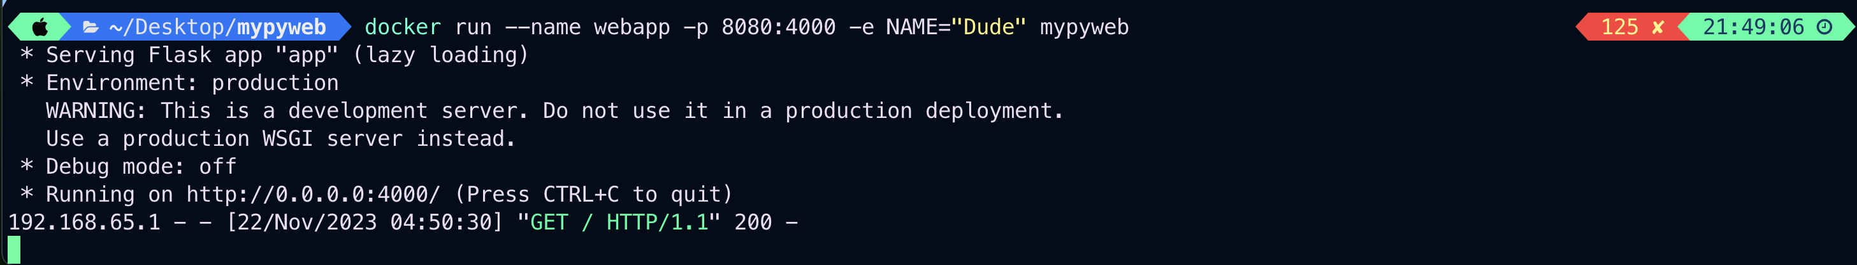



**PART 2: Run a command-line Java program as a Docker image**

**Task 1:**

Building image with docker:

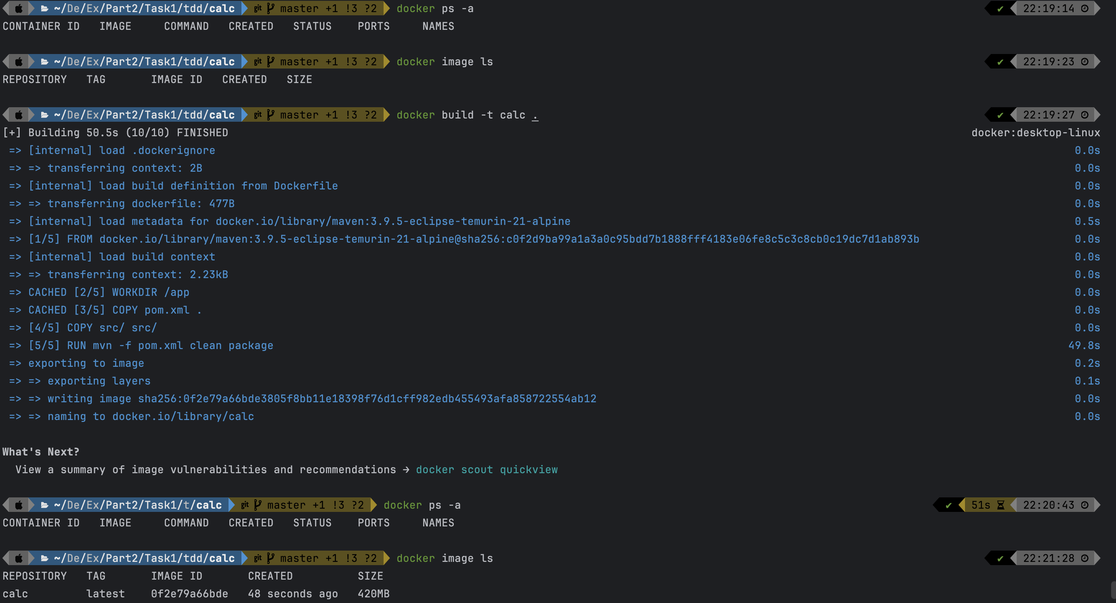



Running with docker:

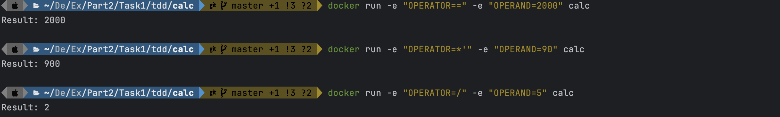



**Readme:**

// "Move to calc directory"

cd calc/

// "Build dockerized app"

docker build -t calc .

// “To run (multiplication operator should follow with quote: *' to solve special character issues in docker)”

docker run -e "OPERATOR==" -e "OPERAND=1000" calc

docker run -e "OPERATOR=*'" -e "OPERAND=900" calc

docker run -e "OPERATOR=/" -e "OPERAND=5" calc

// To remove container

// get container id using

docker ps -a

docker stop <container id>

docker rm <container id>

**Task2:**

Building and Running calcService using docker:

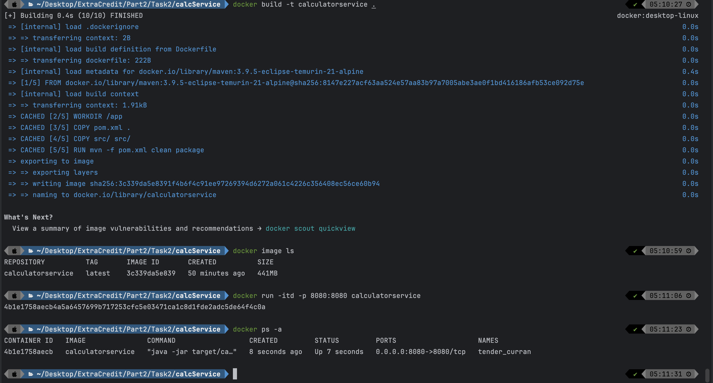

Building and Running calc using docker:

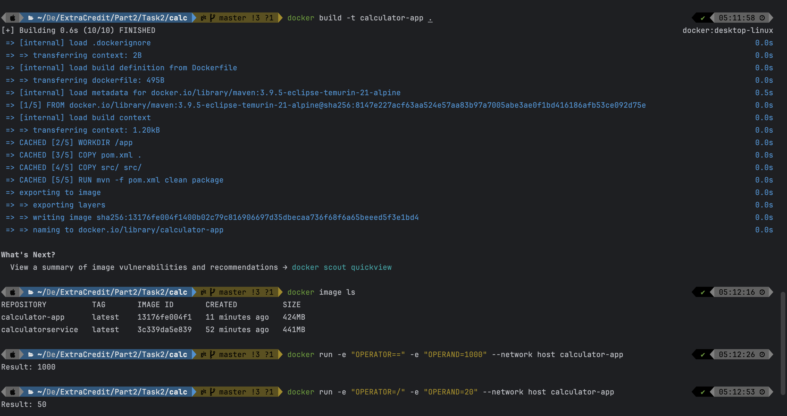

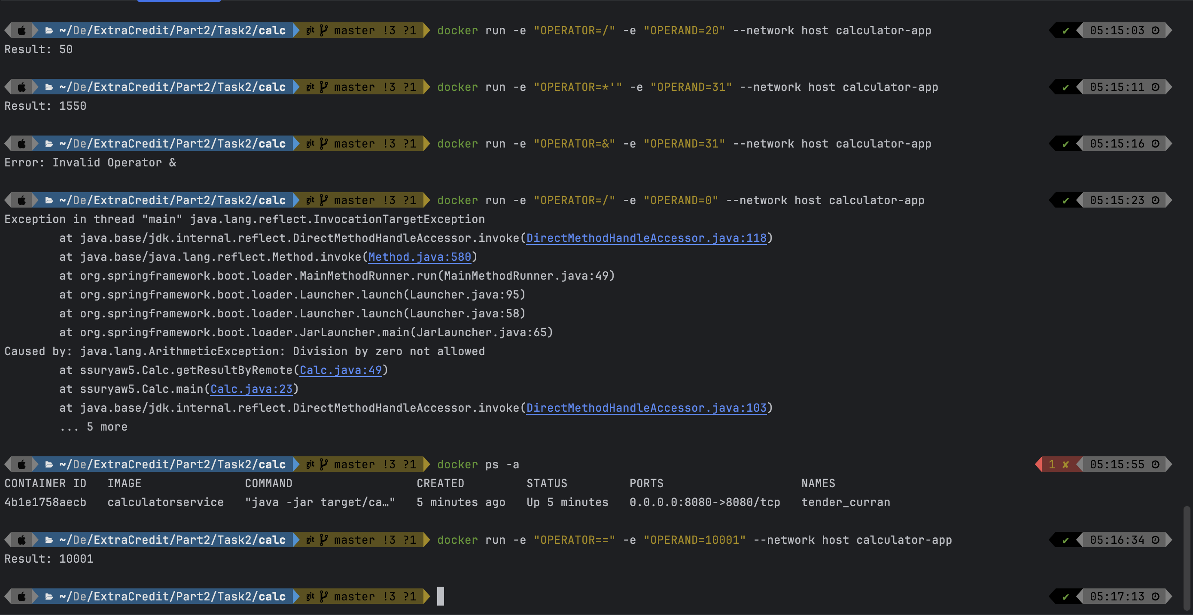

*The api does not crash even in case of exceptions thrown!*

Docker logs command showing incoming request:

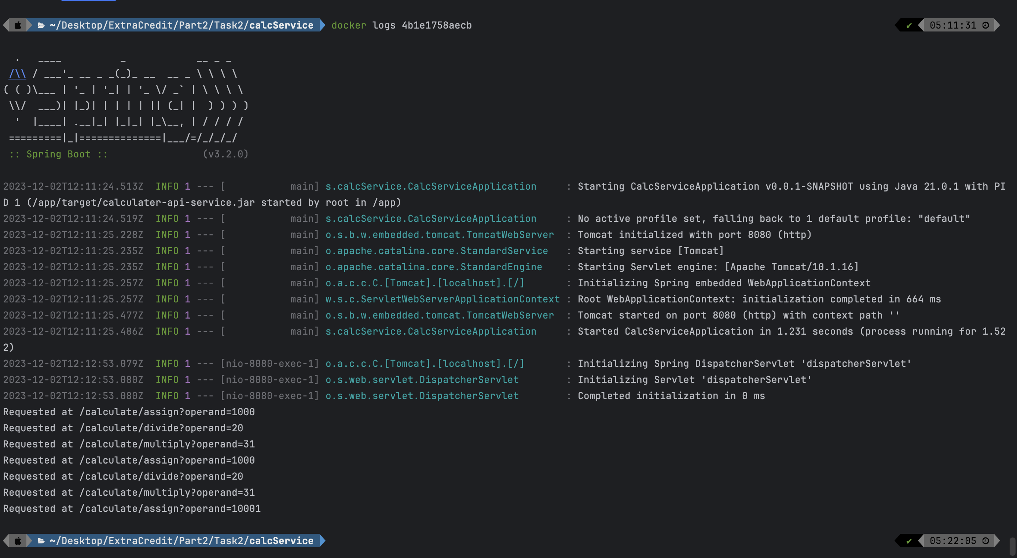

Readme dockerfile_p3t1:

Project strucutre:-

Task2 --

|---calcService

|---calc

|---Readme

Service:

cd calcService

docker build -t calculatorservice .

docker run -itd -p 8080:8080 calculatorservice

// Go to calc folder in terminal

Calc App:

docker build -t calculator-app .

// Run For different operators using commands

docker run -e "OPERATOR==" -e "OPERAND=1000" --network host calculator-app

docker run -e "OPERATOR=/" -e "OPERAND=20" --network host calculator-app

docker run -e "OPERATOR=*'" -e "OPERAND=31" --network host calculator-app

docker run -e "OPERATOR=&" -e "OPERAND=31" --network host calculator-app

docker run -e "OPERATOR=/" -e "OPERAND=0" --network host calculator-app

// Incoming request to service can in seen inside terminal inside calcService

// To get CONTAINER ID

docker ps -a

docker logs <CONTAINER ID>

Project strucutre:-  
  
Task2 --  
 |---calcService  
 |---calc  
 |---Readme  
  
Service:  
 cd calcService  
 docker build -t calculatorservice .  
 docker run -itd -p 8080:8080 calculatorservice  
  
// Go to calc folder in terminal  
Calc App:  
 docker build -t calculator-app .  
  
// Run For different operators using commands  
 docker run -e "OPERATOR==" -e "OPERAND=1000" --network host calculator-app  
 docker run -e "OPERATOR=/" -e "OPERAND=20" --network host calculator-app  
 docker run -e "OPERATOR=*'" -e "OPERAND=31" --network host calculator-app  
 docker run -e "OPERATOR=&" -e "OPERAND=31" --network host calculator-app  
 docker run -e "OPERATOR=/" -e "OPERAND=0" --network host calculator-app  
  
  
// Incoming request to service can in seen inside terminal inside calcService  
  
// To get CONTAINER ID  
  
docker ps -a  
docker logs <CONTAINER ID>

**PART 3: A gentle introduction to microservices**

**Task 1: Docker-compose Tutorial**

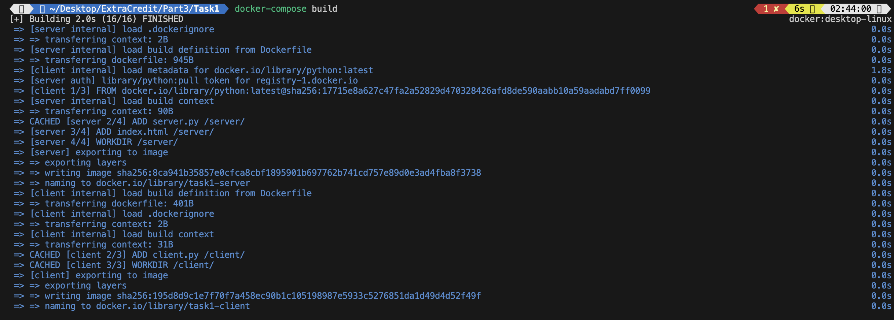

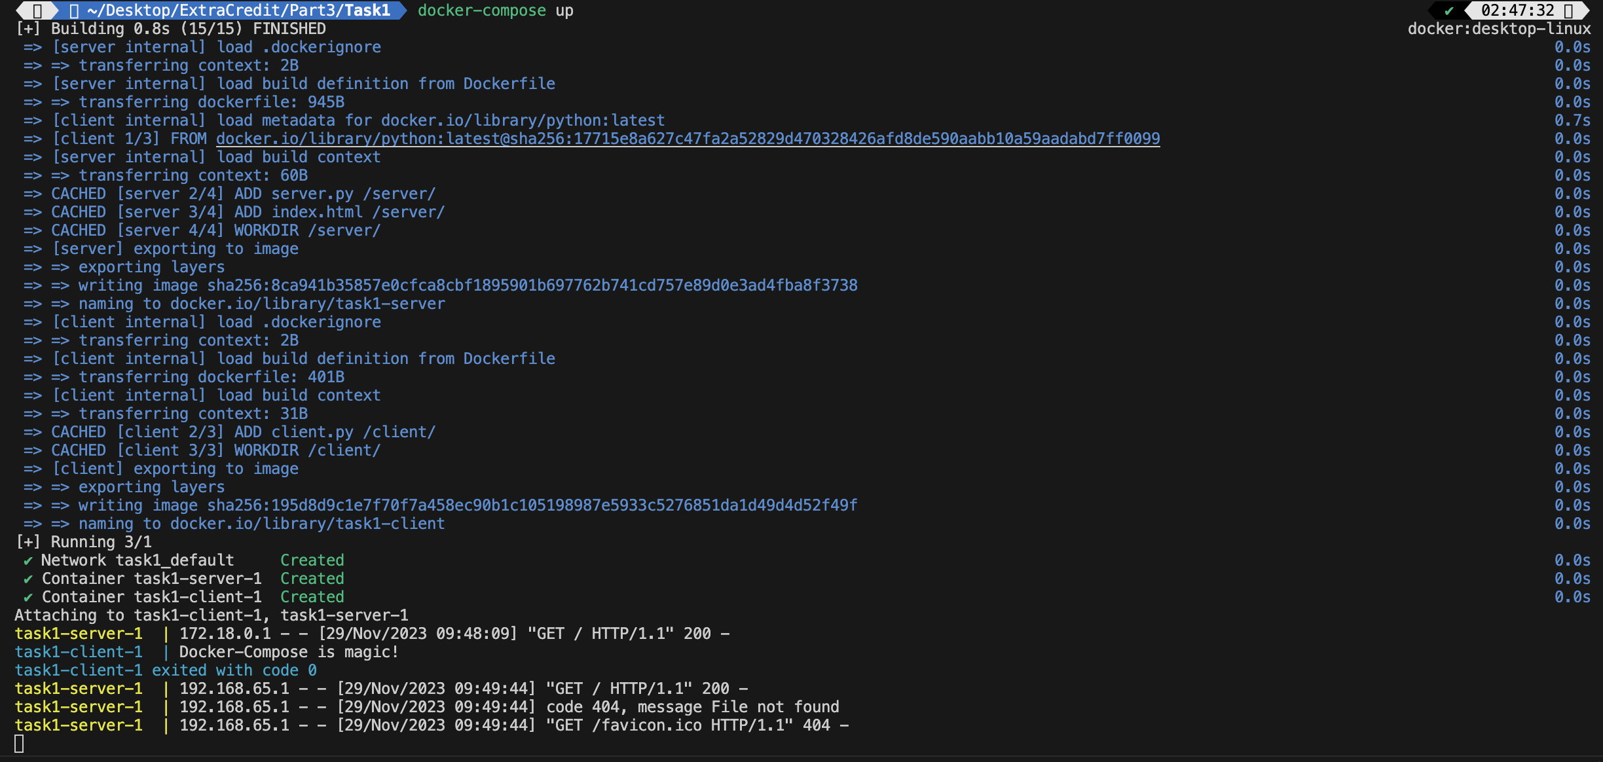



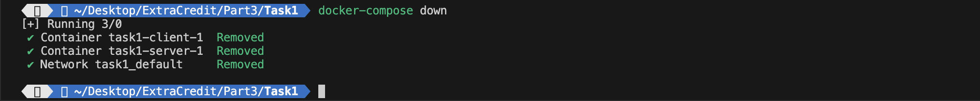

**Task 2: Time to microservice-ize – first try**

Running Task2 calc_service using docker-compose up:

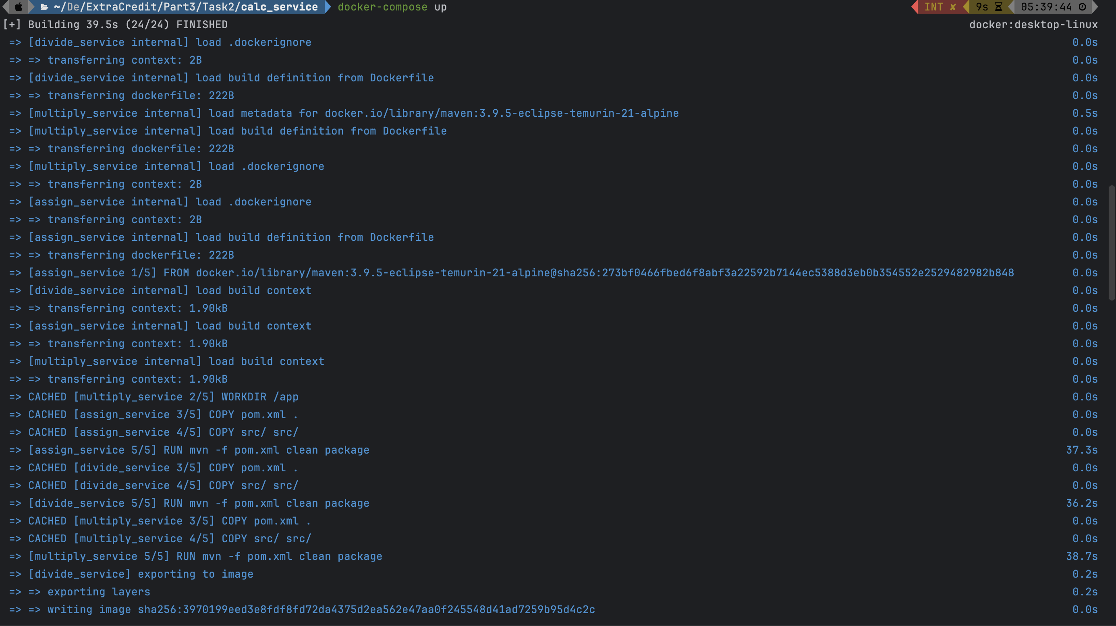

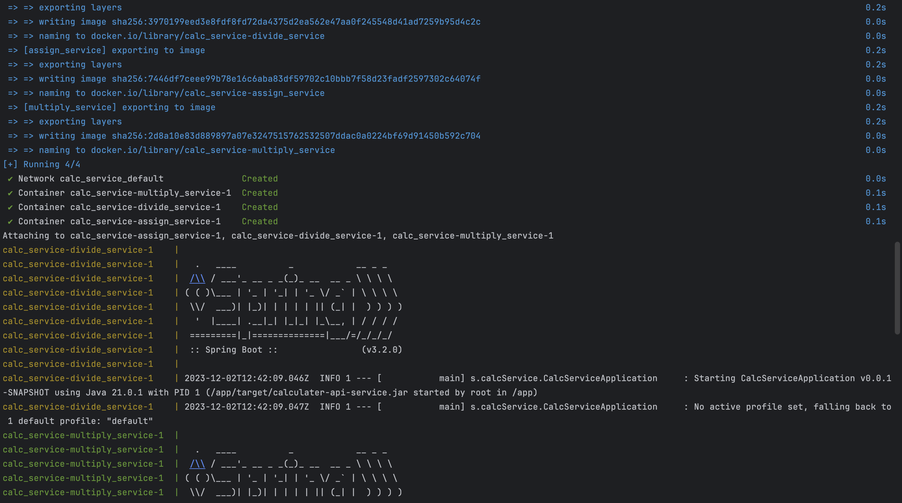

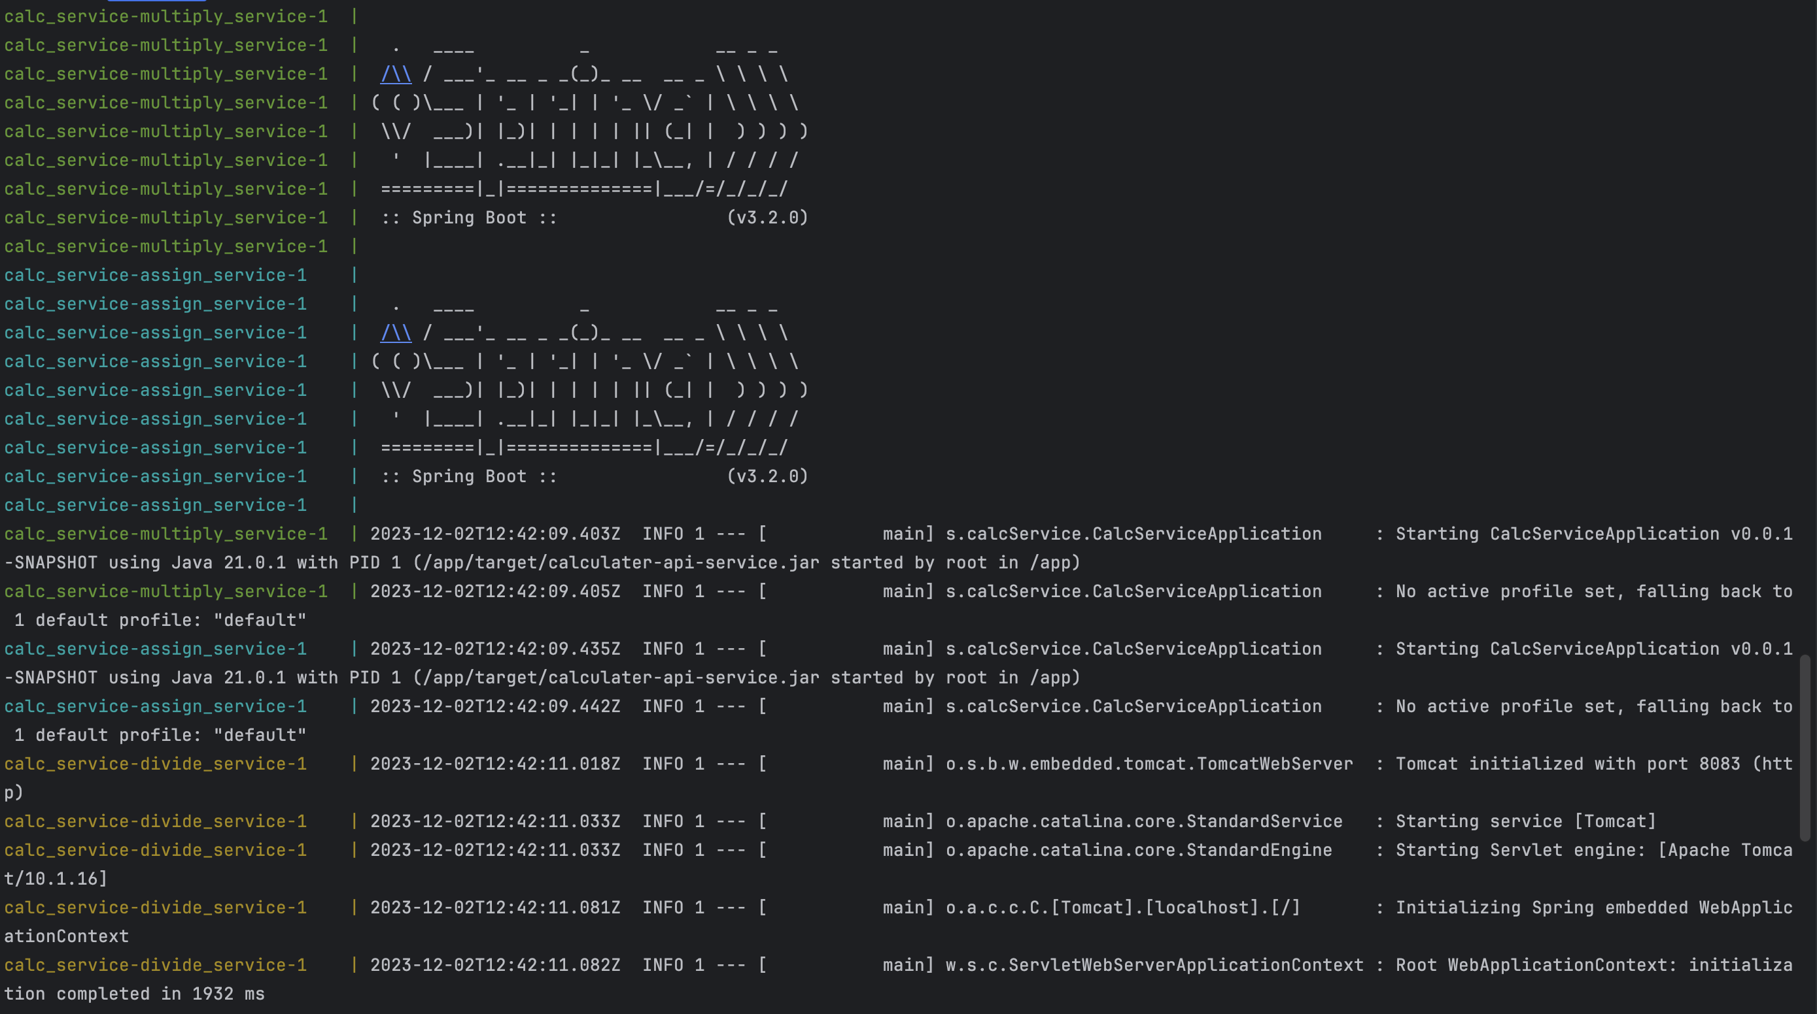

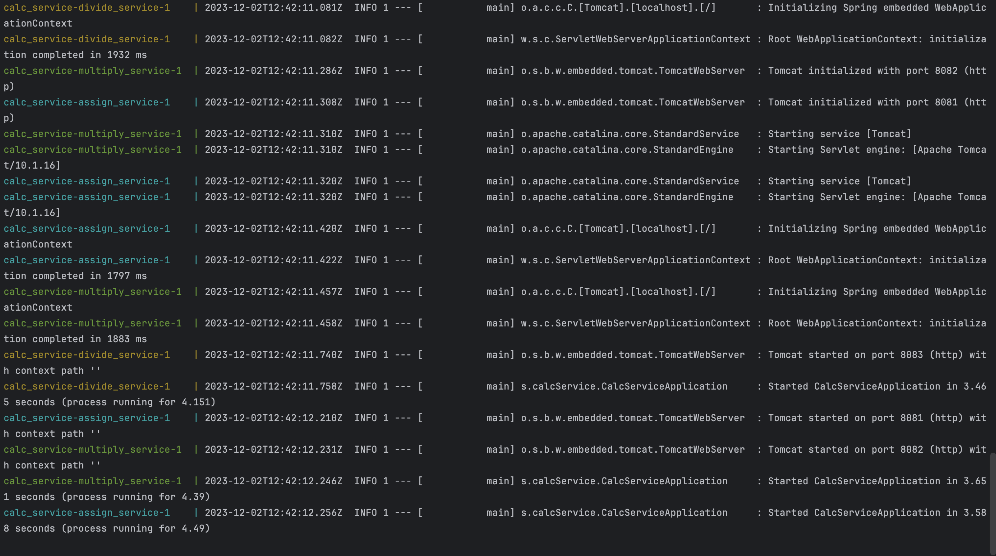

Running calc as a client using docker:

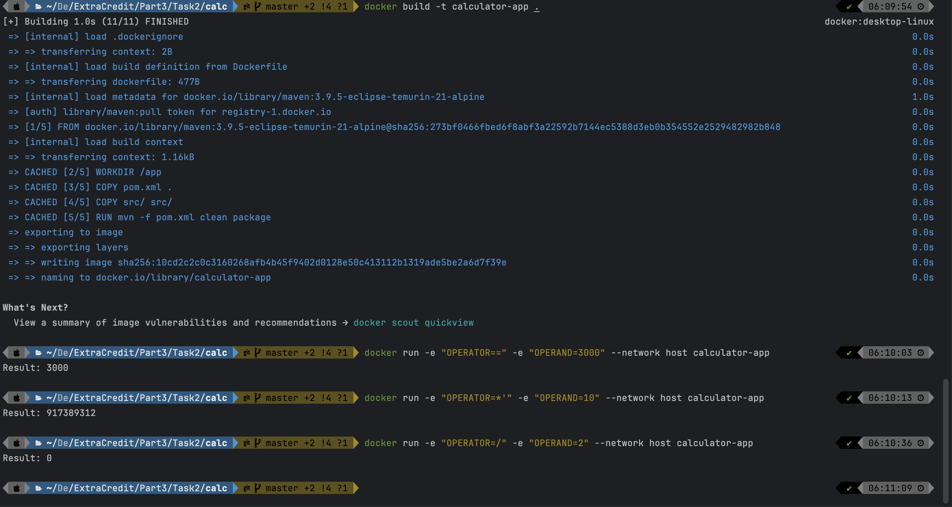

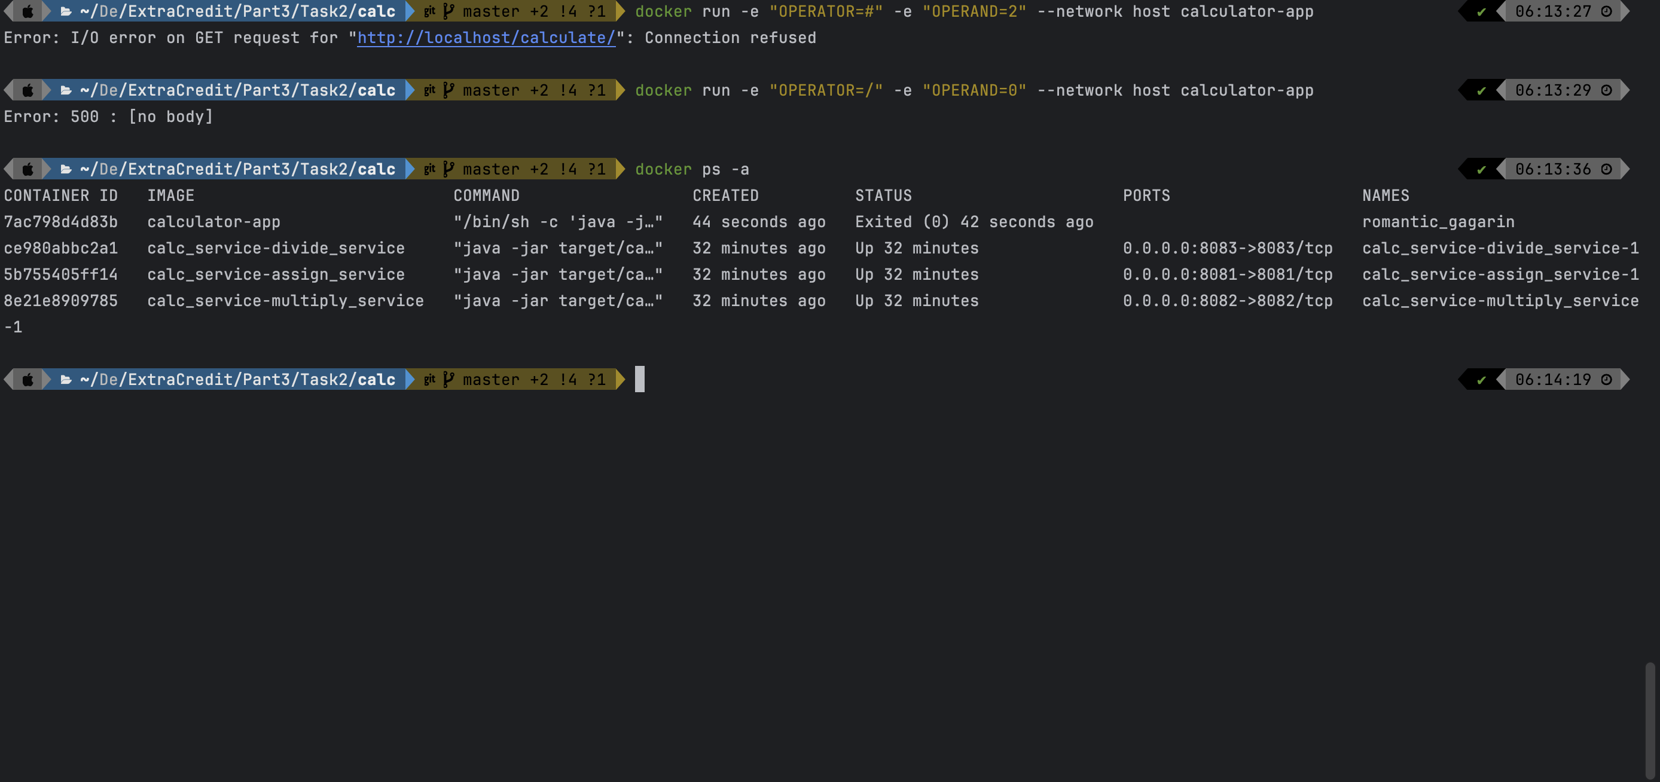

**Task 3:**

Running calc_service:

**Readme: (included in the zip too)**

// Project structure

Task3 --

|--calc

|--Dockerfile

|--calc_service

|--assign_service

|--Dockerfile

|--divide_service

|--Dockerfile

|--multiply_service

|--Dockerfile

|--value-store

|--Dockerfile

|--docker-compose.yml (can ignore if building each service individually)

// Inside calc_service:

// In 4 different terminals

Cd value_store/

docker build -t value_store .

docker run -p 8080:8080 value_store

cd assign_service/

docker build -t assign_service .

docker run -p 8081:8081 assign_service

cd multiply-service/

docker build -t multiply_service .

docker run -p 8082:8082 multiply_service

cd divide_service/

docker build -t divide_service .

docker run -p 8083:8083 divide_service

// -------- OR -----------

// cd calc_service. In terminal

docker-compose up

Since I have included .yml file for ease

// inside different terminal cd calc

// Calc App:

docker build -t calculator-app .

// ----------------- To Run any operator ( = , * , / ) or operand pass it like given below

// docker run -e "OPERATOR=<operator>" -e "OPERAND=<operand>" --network host calculator-app

docker run -e "OPERATOR==" -e "OPERAND=3000" --network host calculator-app

docker run -e "OPERATOR=*'" -e "OPERAND=3000" --network host calculator-app

docker run -e "OPERATOR=/" -e "OPERAND=90000" --network host calculator-app

// Make sure for multiplication case pass an extra ( ' ) after * operator to resolve character exception issues

// To stop the service go to calc_service and hit

// to stop all containers on ur keyboard hit

(ctrl + C)

// and to remove all contianers in terminal

docker-compose down

// To stop the calc go to calc. In terminal

docker stop <container ID>

// (Again you can get container ID by docker ps -a)

// To remove the calc container. In terminal

docker rm <container ID>

Running calc using docker :

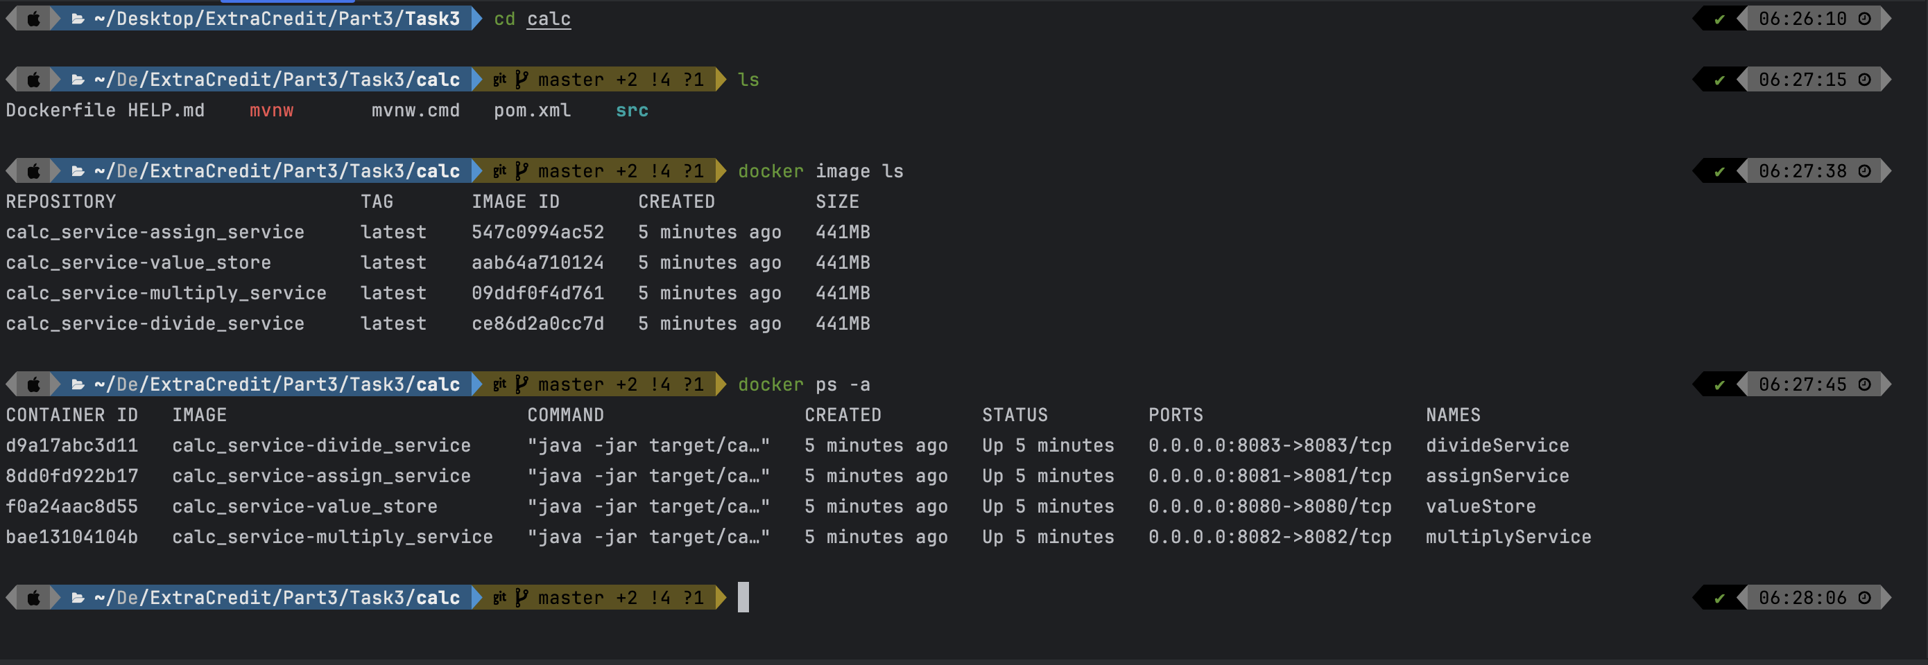

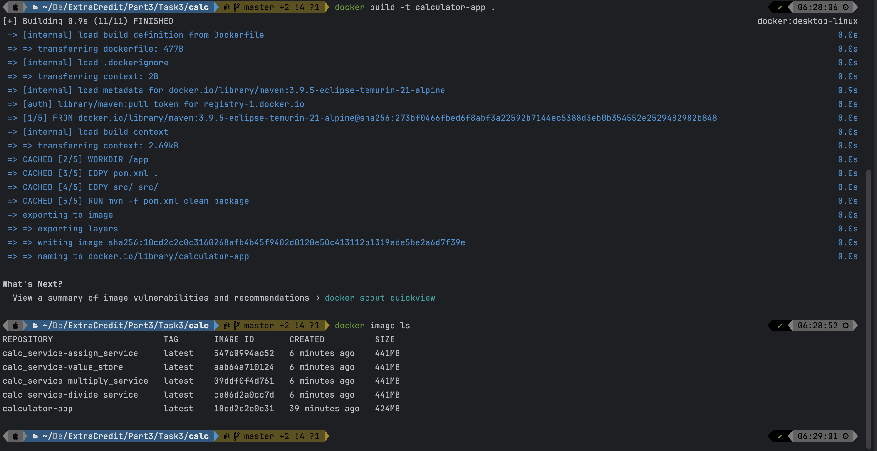

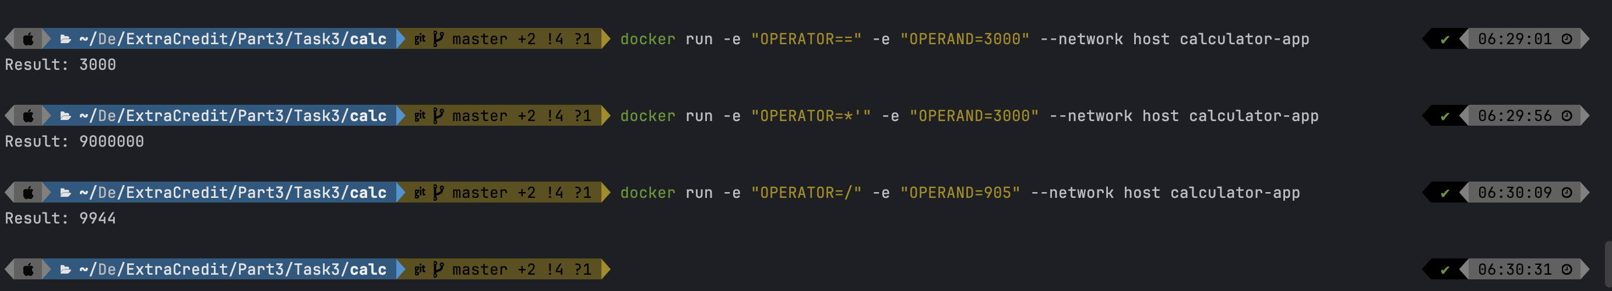

Value stays store!!

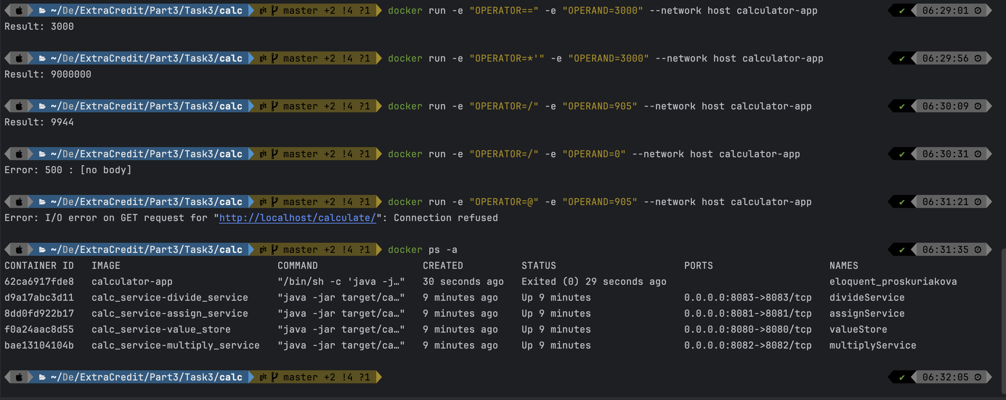

Stopping and removing contianers:

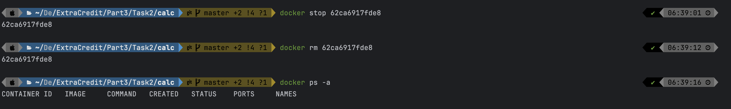

**Task 4: Network**

Running calc_service using docker:

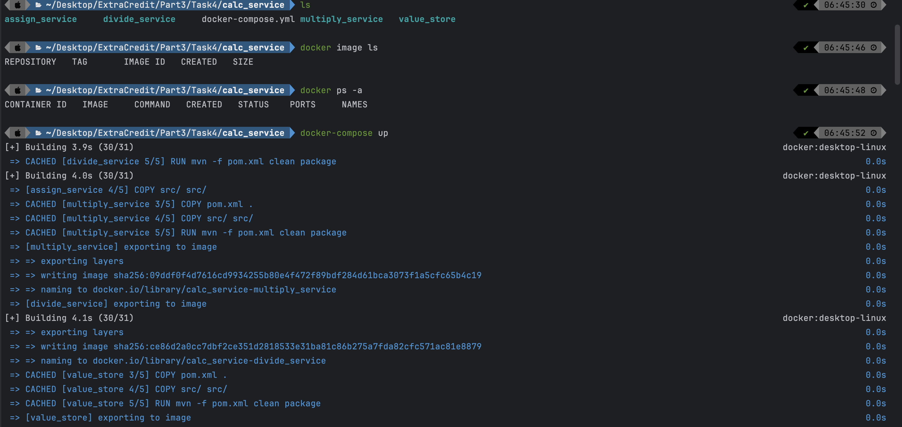

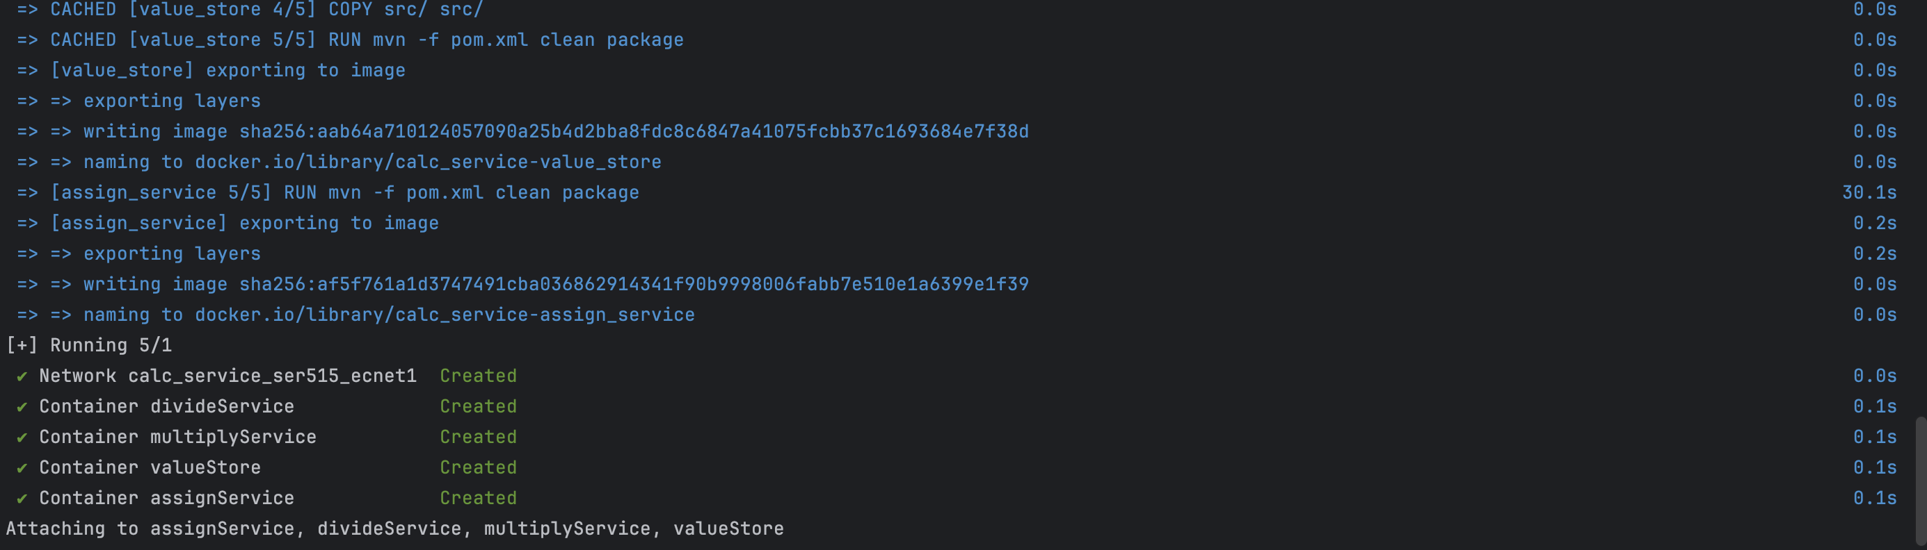

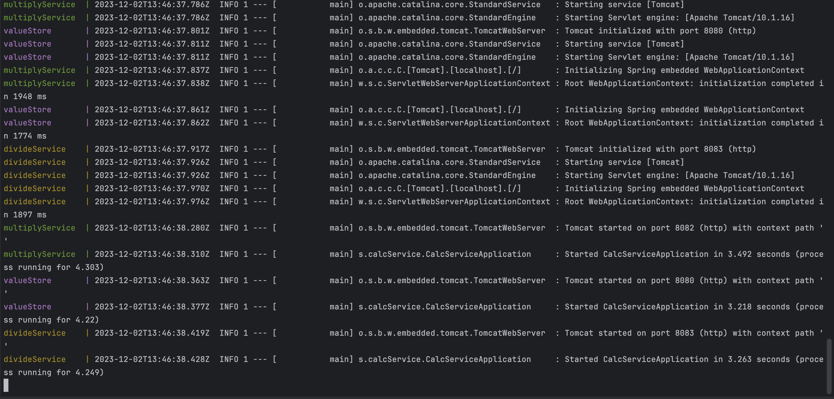

Running calc using docker:

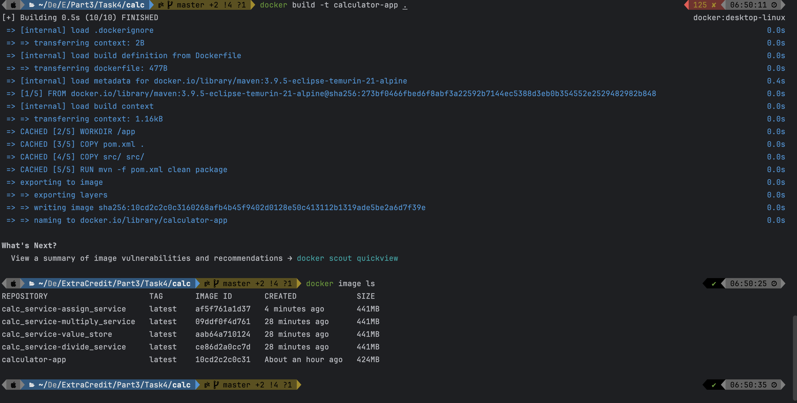

Lets check network:

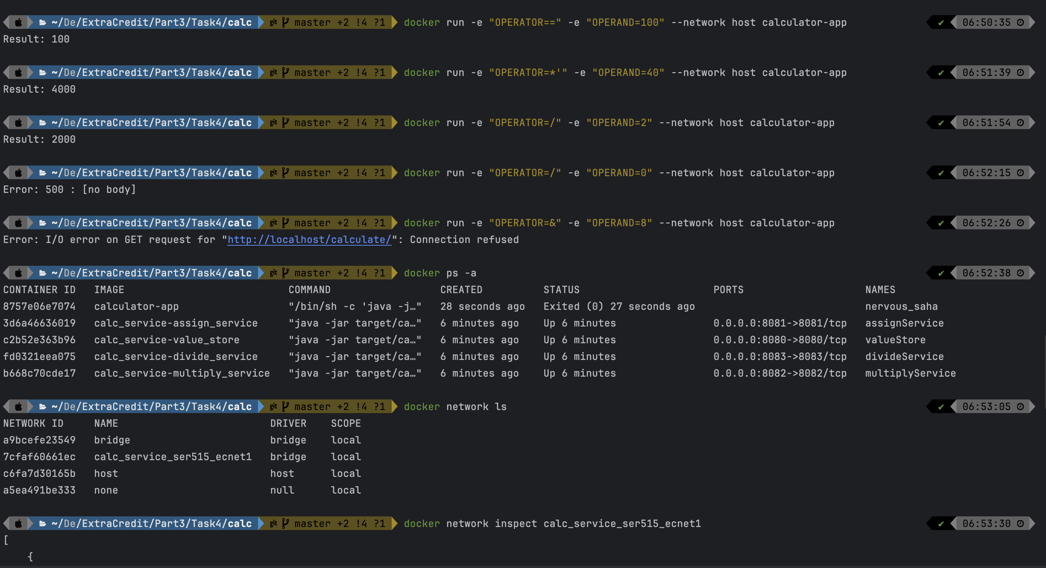

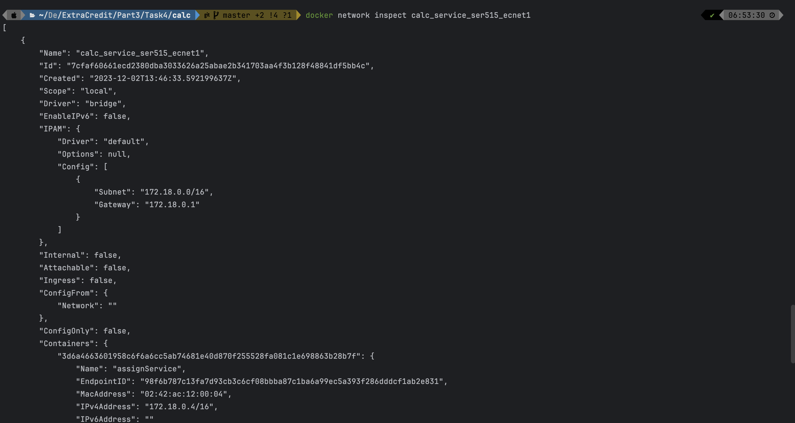

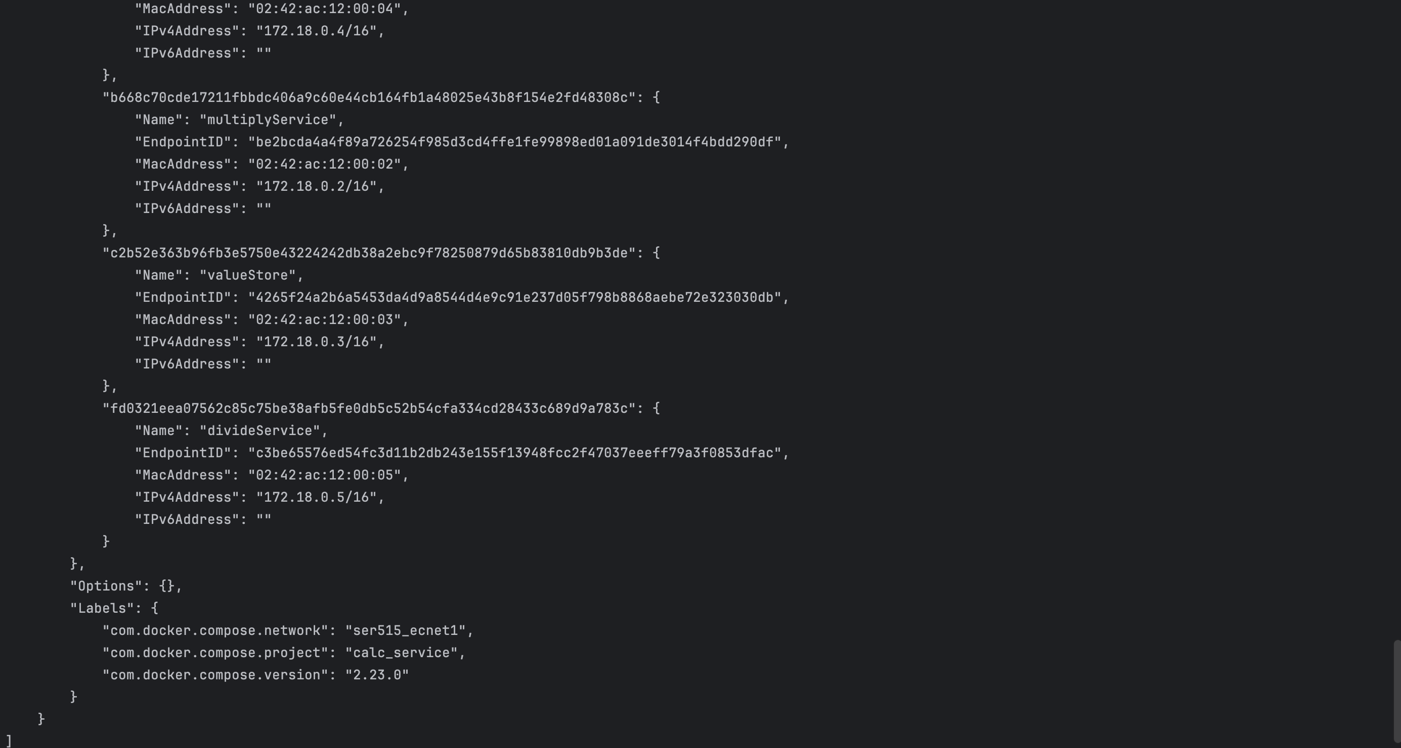

**Task 5: single access point to the client**

Running calc_service using docker:

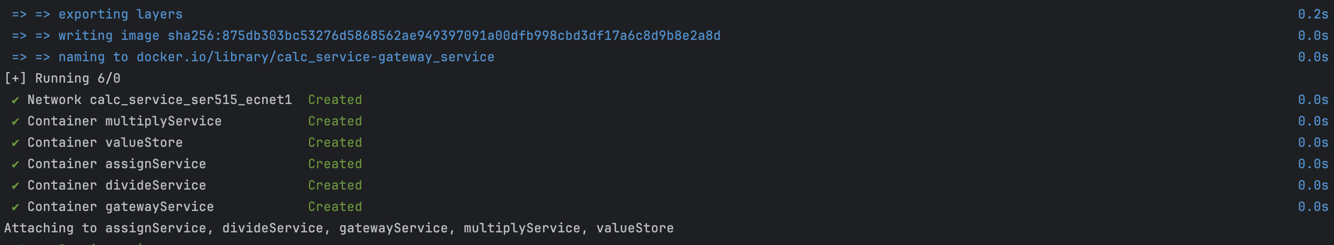

Running calc using docker:

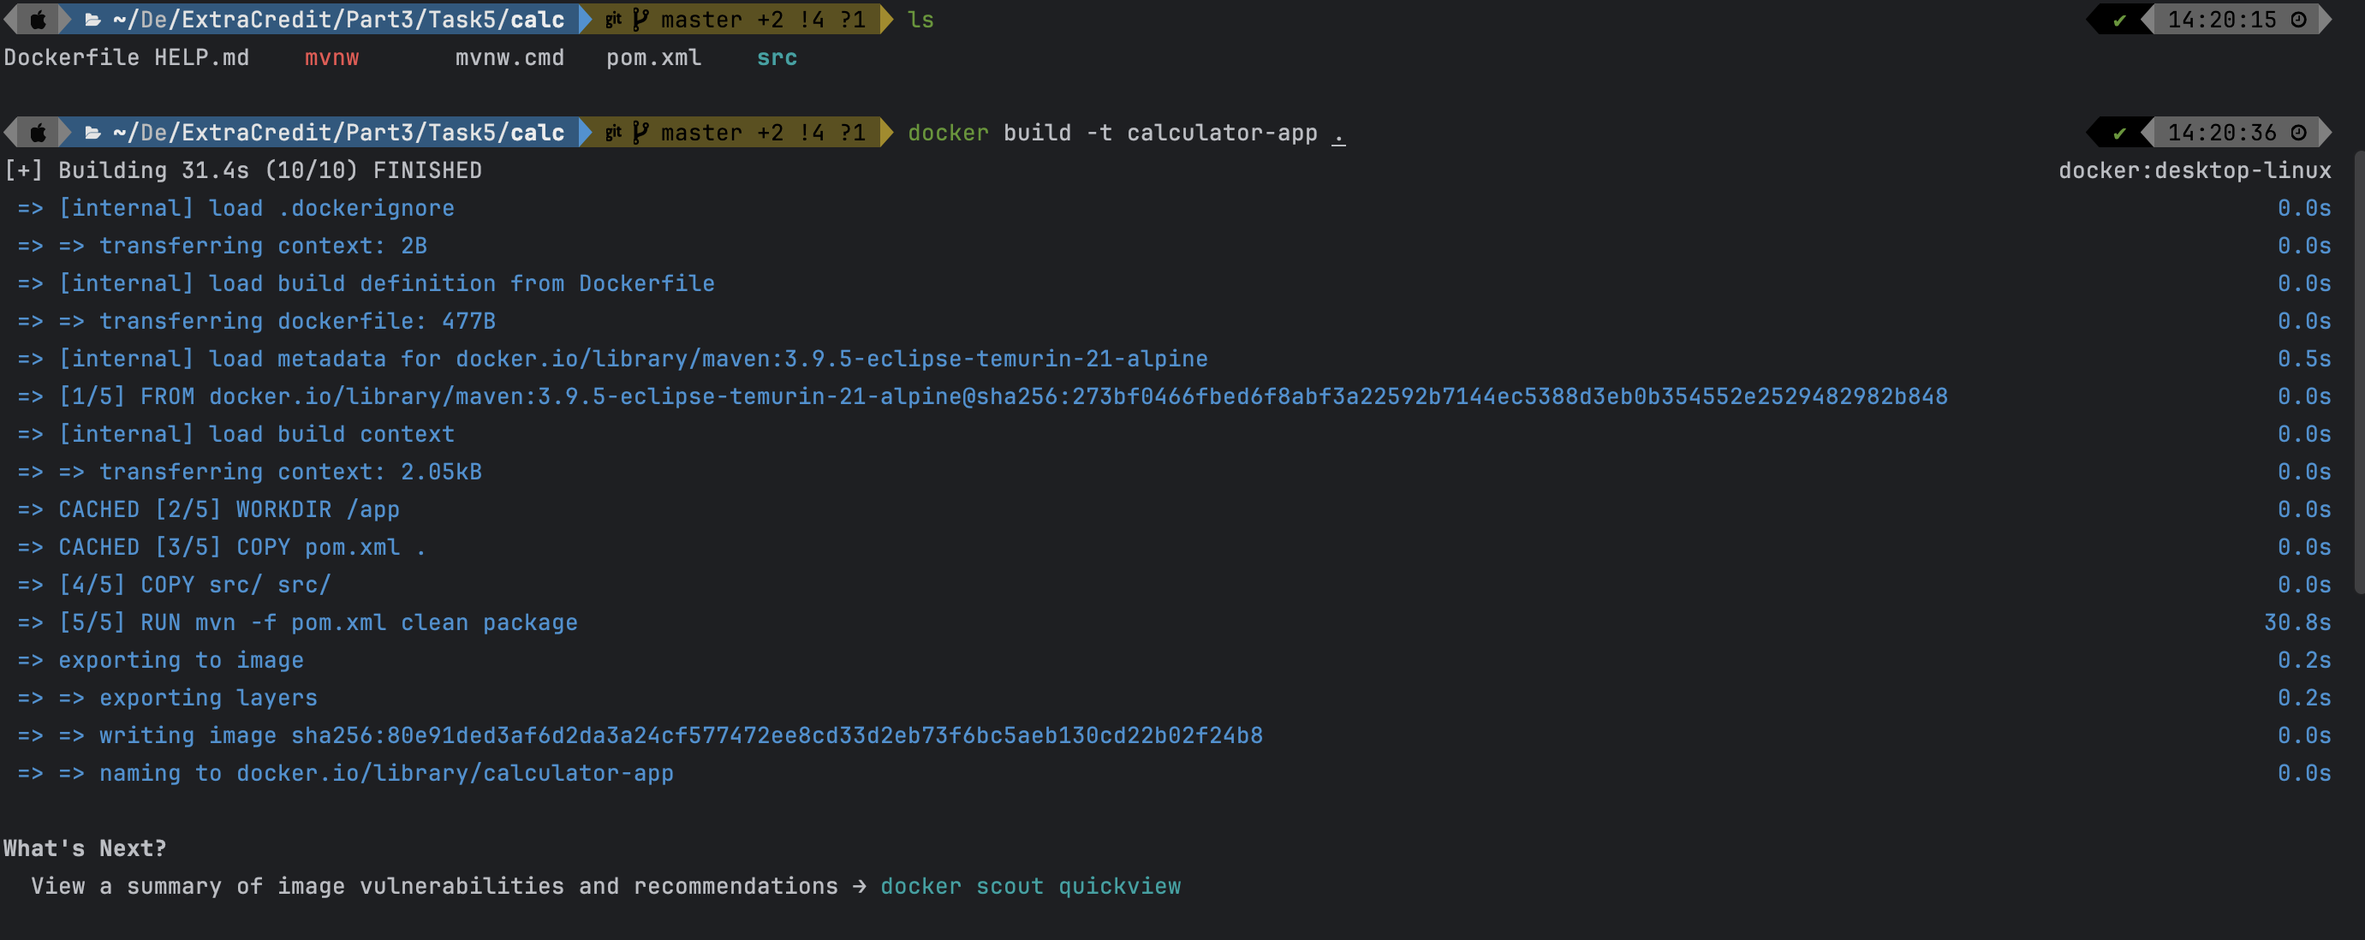

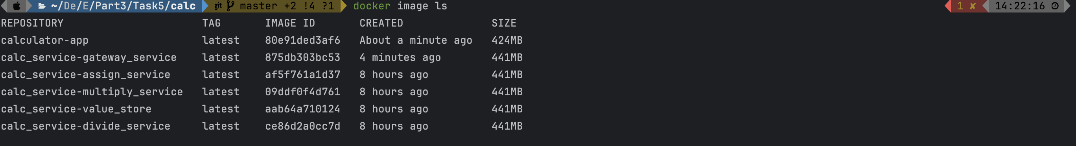

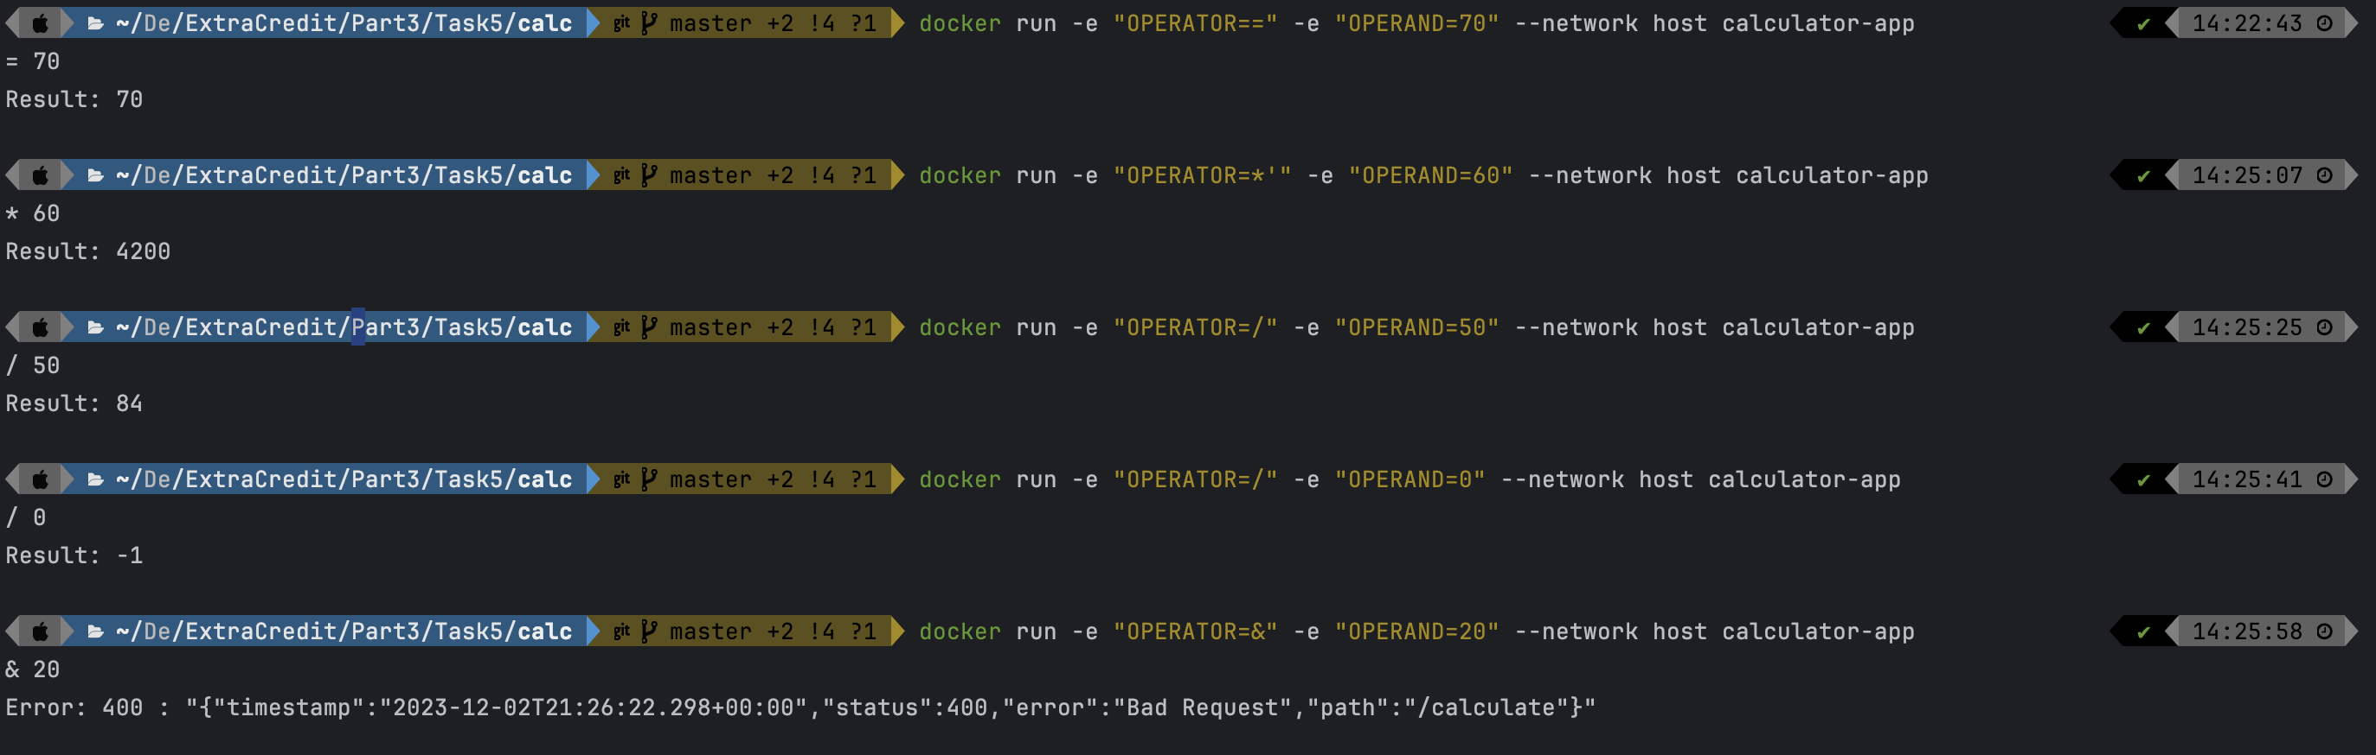

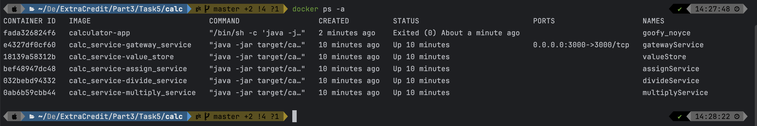

**Task 6:**

Running calc_service:

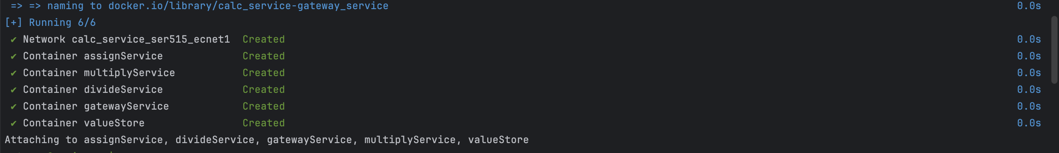

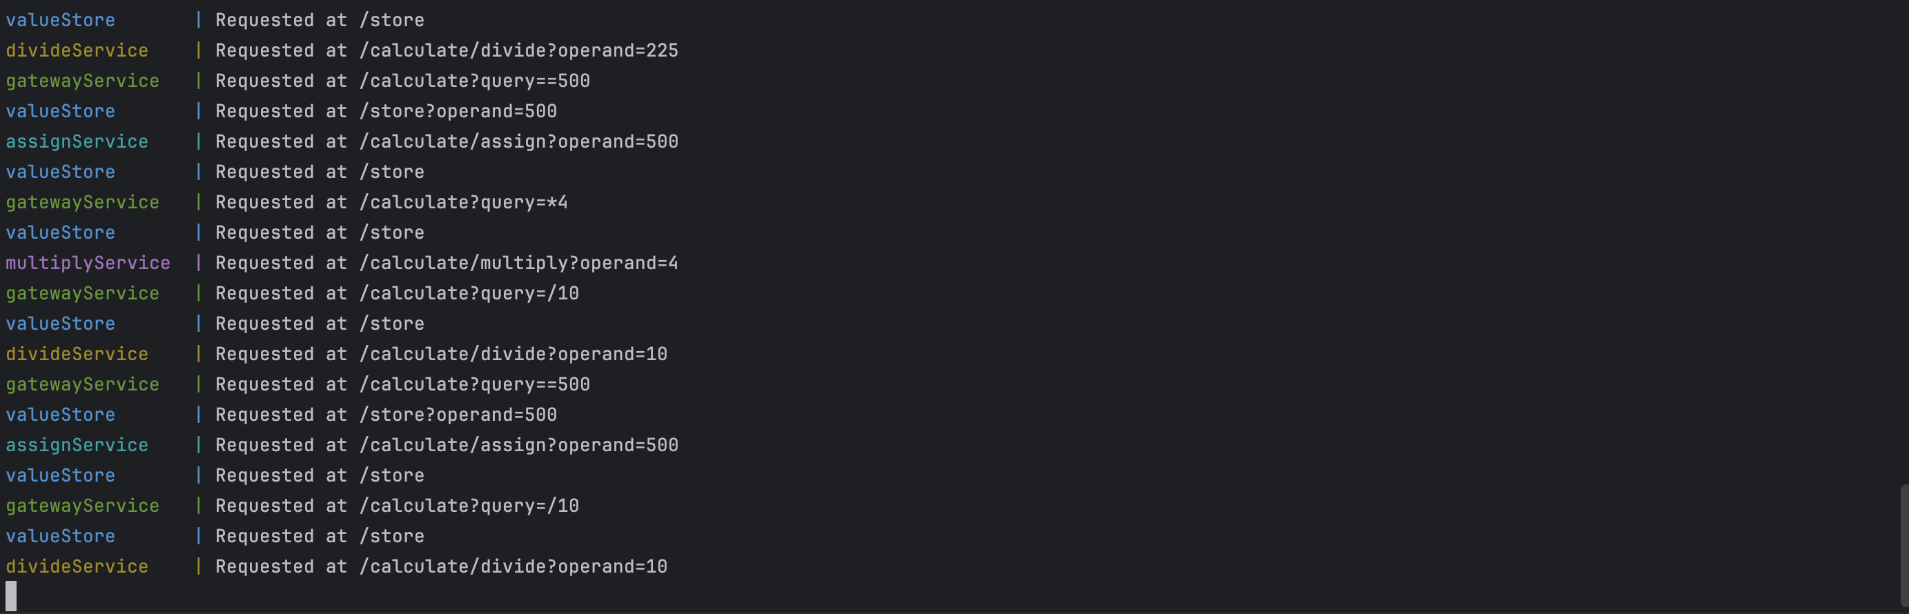

Running calc using docker:

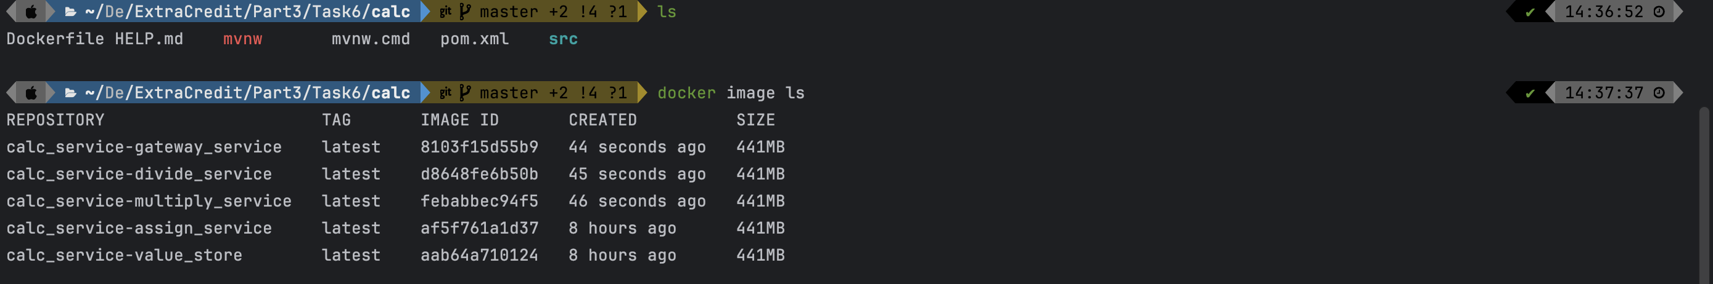

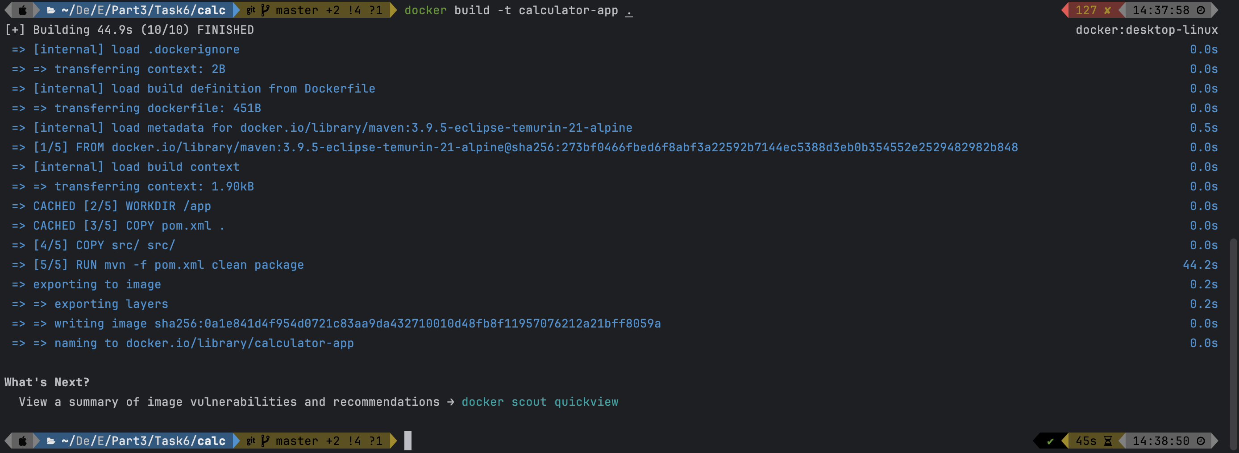

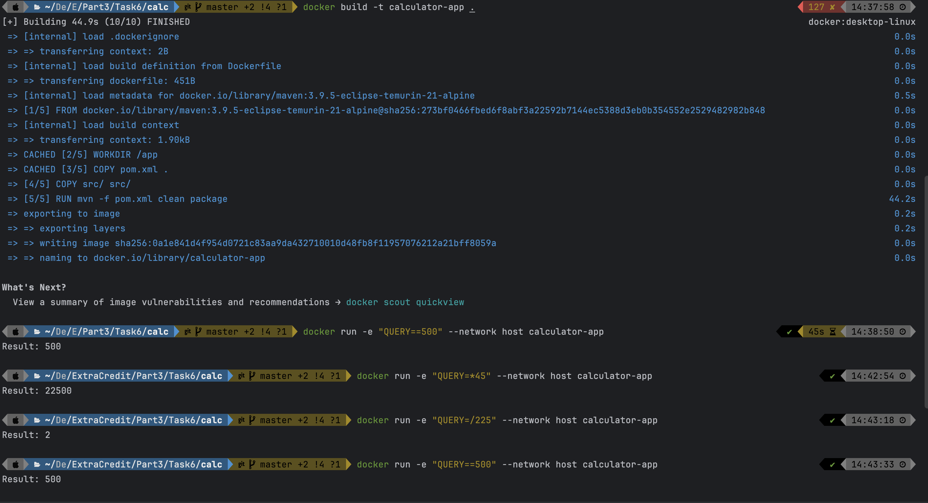

Network:

